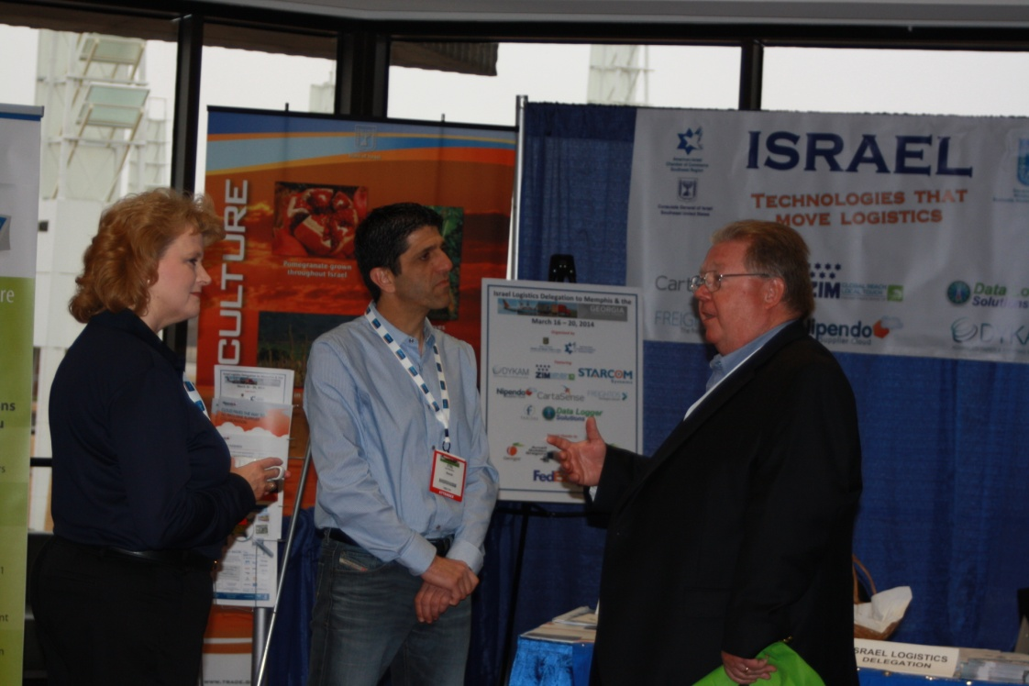
Eyal Rosenberg- Nipendo, Vikki Lisec – Datalogger Solutions in a meeting at the Israeli booth
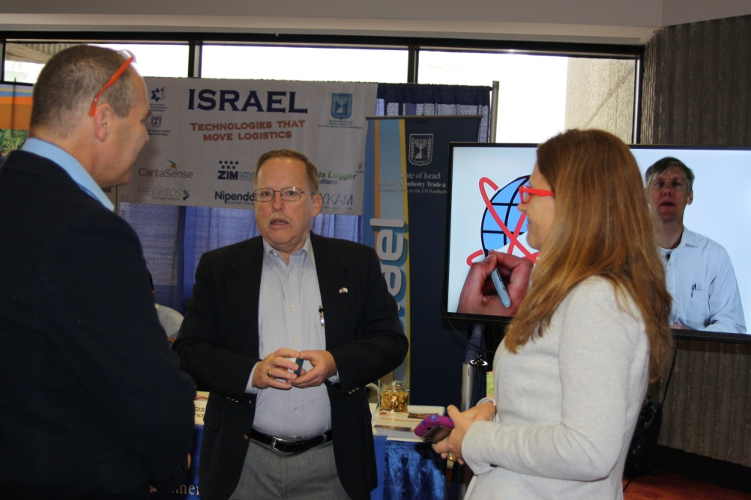
Left: Iftach Amami, Right: Karina Rubinstein - Dykam. In a meeting and the Israel booth

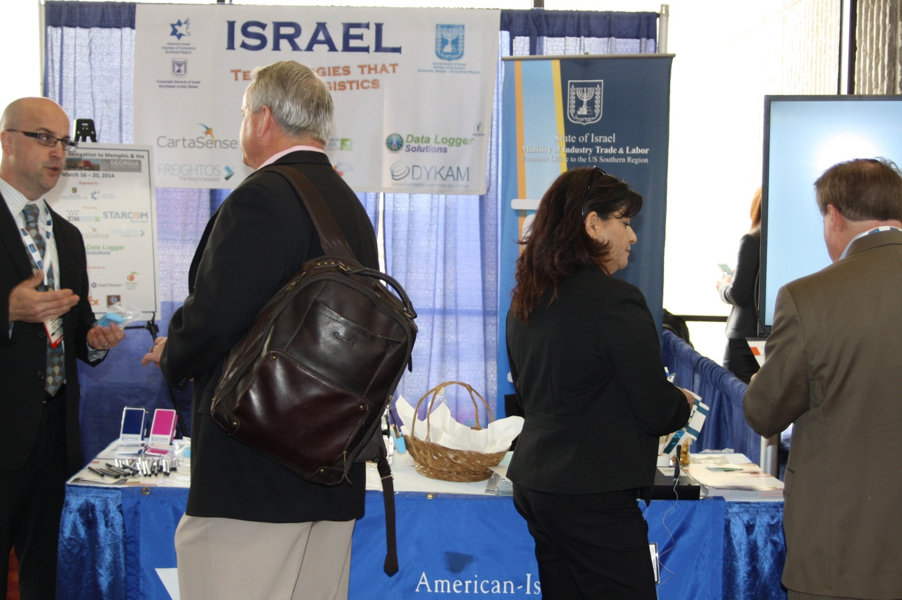
From left: Judd Bare – Zim Shipping, Right: Yael Leshem – CartaSence.
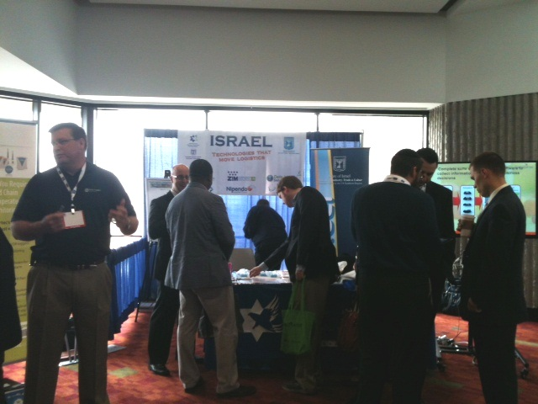
Israeli Booth Georgia Logistics: From left: Scott Lisec – Datalogger Solutions, Judd Bare – Zim Shipping, Avi Shapiro – Freightos (back to camera)
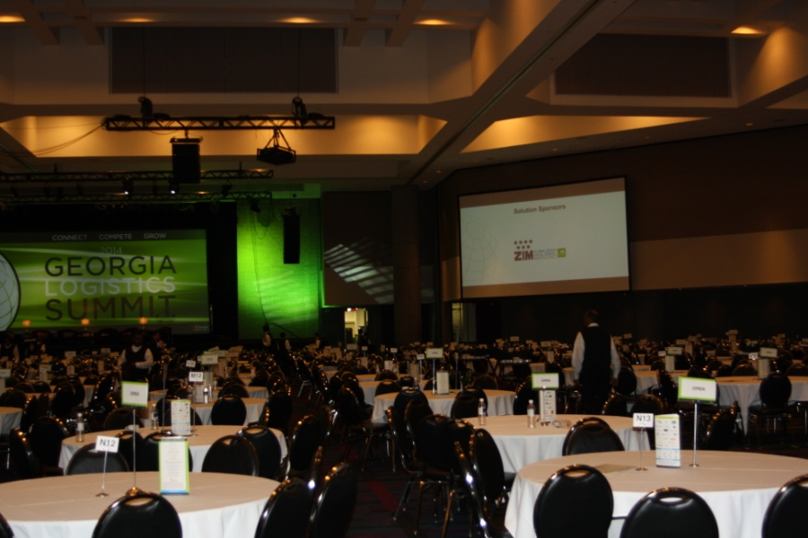
Zim Shipping on the board of the main conference hall
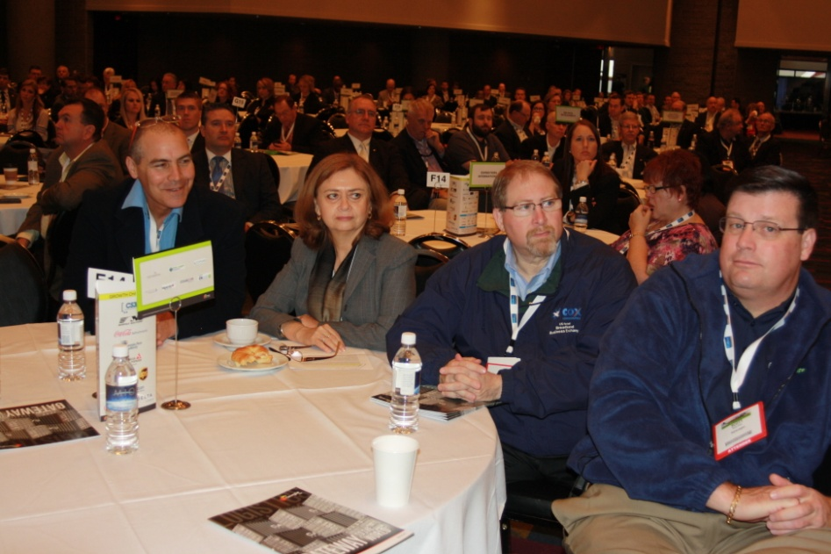
From left: Iftach Amami- Dykam, Bracha Shlomo – Israel Economic Mission, Berry Swartz – American-Israel Chamber of Commerce SE, Scott Lisec – Datalogger Solutions

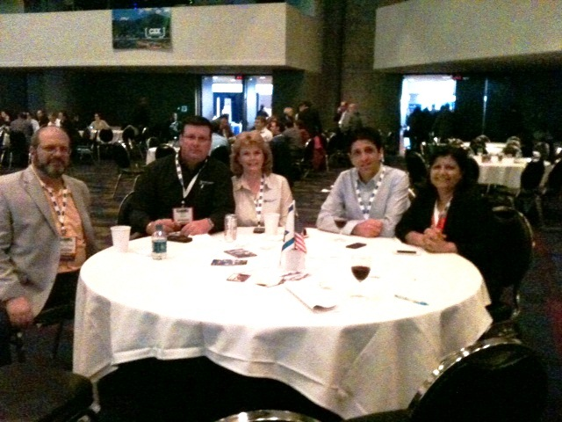
From left: Guy Tessler - American-Israel Chamber of Commerce SE, Scott Lisec & Vikki Lisec ,– Datalogger Solutions, Eyal Rosenberg- Nipendo, Yael Leshem – CartaSence.

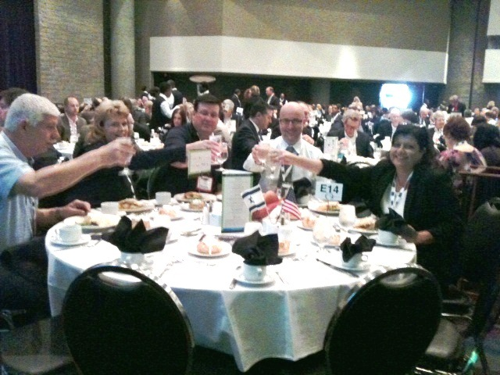
From left: Moshe Shtouber- Starcom Systems Ltd., Vikki Lisec , Scott Lisec – Datalogger Solutions, Judd Bare – Zim Shipping, Yael Leshem – CartaSence

